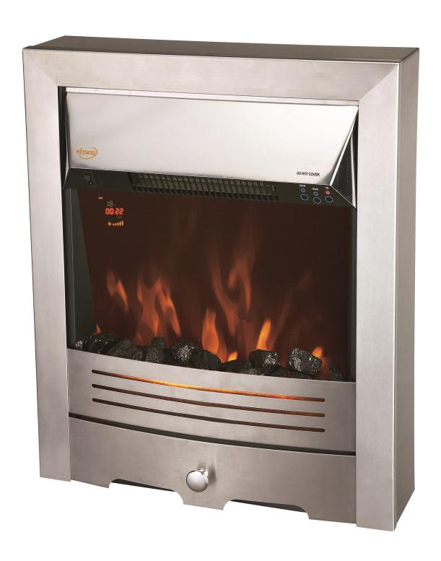

HDi Electric fire

Suitable for 16” and 18” Fireplaces

Instruction Manual
Model: NDY-19ER-E
This product is only suitable for well insulated spaces or occasional use.
Read instructions thoroughly before use and keep for future reference.

IMPORTANT SAFETY INSTRUCTIONS – PLEASE READ!!!
Please read the instructions below carefully before installation or using your Electric Heater, and retain for future reference. Before connecting the heater to the power supply, please remove the two pieces of foam from the rear. Please do not pull or carry the heater by any edge to avoid potential injury.

- The heater must not be located immediately below a socket outlet.
- Do not use this heater in the immediate surroundings of a bath, a shower or a swimming pool.
· NEVER leave unsupervised children where the heater is left switched ON or is left unguarded.
- NEVER leave the heater unattended. Turn off when not used.
- NEVER touch the unit when it's turned on.
- NEVER install the heater close to combustible material i.e. curtains or similar. Allow a minimum of one meter around the heater.
- NEVER route the mains cable beneath carpet.
- NEVER use aerosols or similar products close to the heater.
- NEVER use the heater to dry clothes or similar articles.
- NEVER use the heater by means of an automatic control or timer.
- The appliance MUST be disconnected from the mains supply before cleaning or maintenance.
- Warning: In order to avoid overheating, do not cover the heater.
- Use a suitable fireguard to protect young children who could come into contact with the heater.
- Never use an appliance if the supply cord is damaged. If the supply cord is damaged, it must be replaced by the manufacturer, its service agent or similarly qualified persons in order to avoid a hazard.
- Dot use this heater with a programmer, timer or any other device that switches the heater on automatically, since a fire risk exists if the heater is covered or positioned incorrectly.
- This appliance is not intended for use by persons (including children) with reduced physical, sensory or mental capabilities, or lack of experience and knowledge, unless they have been given supervision or instruction concerning use of the appliance by a person responsible for their safety.
- Children should be supervised to ensure that they do not play with the appliance.
- WARNING: This heater is not equipped with a device to control the room temperature. Do not use this heater in small rooms when they are occupied by persons not capable of leaving the room on their own, unless constant supervision is provided.
- WARNING: In order to avoid a hazard due to inadvertent resetting of the thermal cutout, this appliance must not be supplied power through an external switching device, such as a timer, or connected to a circuit that is regularly switched on and off by the utility.
Information requirements for electric local space heaters
Model identifier(s): NDY-19ER-E
Item | Symbol | Value | Unit |  | Item | Unit
Heat output |  |  |  |  | Type of heat input, for electric storage local space heaters only (select one)
Nominal heat output | P_{nom} | 1.9 | kW |  | manual heat charge control, with integrated thermostat | N/A
Minimum heat output (indicative) | P_{min} | 0.95 | kW |  | manual heat charge control with room and/or outdoor temperature feedback | N/A
Maximum continuous heat output | P_{max,c} | 1.9 | kW |  | electronic heat charge control with room and/or outdoor temperature feedback | N/A
Auxiliary electricity consumption |  |  |  |  | fan assisted heat output | N/A
At nominal heat output | el_{max} | 0.014 | kW |  | Type of heat output/room temperature control (select one)
At minimum heat output | el_{min} | 0.014 | kW |  | single stage heat output and no room temperature control | [no]
In standby mode | el_{SB} | 0.48 | W |  | Two or more manual stages, no room temperature control | [no]
 |  |  |  |  | with mechanic thermostat room temperature control | [no]
 |  |  |  |  | with electronic room temperature control | [no]
 |  |  |  |  | electronic room temperature control plus day timer | [no]
 |  |  |  |  | electronic room temperature control plus week timer | [yes]
 |  |  |  |  | Other control options (multiple selections possible)
 |  |  |  |  | room temperature control, with presence detection | [no]
 |  |  |  |  | room temperature control, with open window detection | [no]
 |  |  |  |  | with distance control option | [no]
 |  |  |  |  | with adaptive start control | [yes]
 |  |  |  |  | with working time limitation | [no]
 |  |  |  |  | with black bulb sensor | [no]
Contact details | Heat Design, Unit 60 Hawthorn Road, Western Industrial Est,  Naas Road, Dublin 12

Installation Requirements
- The Electric heater is supplied with approximately 1.7 meters of flexible mains cable (1mm²⁾.The appliance and surround should be located close to a suitable mains socket and MUST be easily accessible to allow proper connection.
- This appliance must not be directly installed on a carpet or similar material. We recommend that it is fitted onto a hearth or similar non-combustible material.
- This heater MUST be earthed. If in any doubt consult the manufacturer, its service center or a qualified person.

Built-in Installation
The heater is suitable for installation into a location that has an opening size within the guidelines shown below:
Width Minimum 15 1/2”/390mm Maximum 19”/483mm
Height Minimum 21 3/4”/555mm Maximum 23 1/4”/590mm
Depth Minimum 4 1/4”/110mm Maximum 5”/125mm
- The installation size as below indicated.
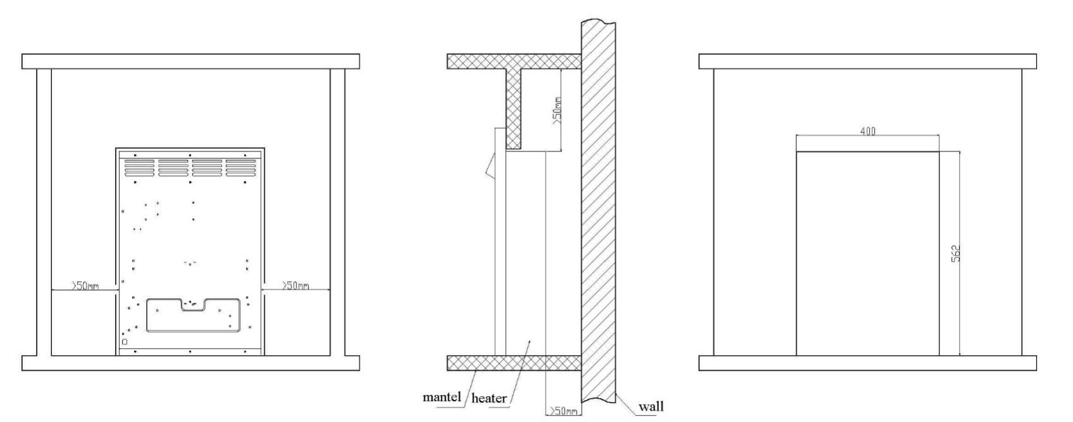

Unpacking the Appliance
- The Electric Heater is supplied in a single pack carton.
- All instructions should be read prior to unpacking or installing the appliance.
- Ensure all parts including loose items have been removed prior to discarding the packaging.

Product Checklist
1 piece: Electric heater (Stainless Steel Surround)
1 piece: Coals pack
1 piece: Log pack
1 piece: Instruction manual
1 piece: Remote control (Battery’s included)

Standby status
The fire displays standby symbol and timer symbol (No timer symbol if no timing setting or the button on remote control at OFF position)

Switch on status
· The fire displays date/time, room temperature and flame brightness level. Please set the actual date/time by the end user when first use.

Instructions for Use
· The appliance can be operated either by the touch switches located at the right hand side of the fire
canopy or by supplied remote control.

Manual Operation
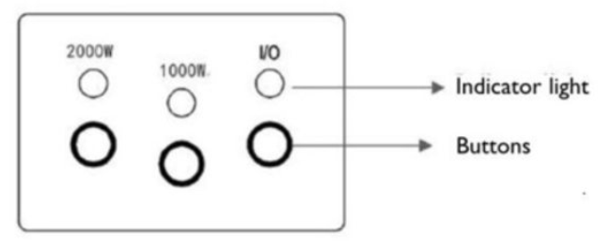

- The standby switch at the left hand side of the fire canopy must be first switch on.
- Press once the O/I button to turn on the appliance and fire effect. A red indicator light will appear to indicate that the function is ON. Press the O/I button for 3 seconds this will operate the dimmer mode. There are 5 levels flame brightness available.
- Press once the 1000W button for the low heat settings, a red indicator light will appear to indicate the function; press twice to switch off the heat setting.
- Press once the 2000W button for the high heat settings, a red indicator light will appear to indicate the function; press twice to switch off the heat setting.
- Press the DIMMER button for operate the dimmer mode. There are 5 levels flame brightness available.
- NOTE: The set temperature must be higher than the room temperature for the fan heater to function.

Remote Operation

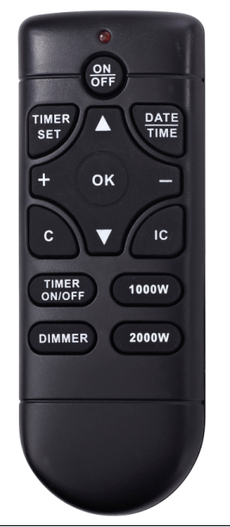

Flame brightness adjustment
· Press "DIMMER" button on the remote control, the flame brightness may change step by step with each press of the button

Temperature setting
· Press "+" or "-" button on the remote control to set the temperature, which ranges from 15 to 30℃, and this is the normally set temperature (the timer is off). The default set temperature is 20 ℃.
· Note: The set temperature must be higher than the room temperature for the heat working.

Heating operations
· Press the ON/OFF button once on the remote control this turns ON/OFF the fire and flame effect.
· Press the "1000W" button once to turn the low-level heating 1000W on and press twice to stop heating.
· Press the "2000W" button once to turn the high-level heating 2000W on and press twice to stop heating.
· Note: The set temperature must be higher than the room temperature for the heat working.

Automatic heating operations (Intelligent Control)
· Press "IC" button on the remote control to turn on or turn off the automatic heating.
· When turned on, the fire can automatically change the heating mode depending on the set temperature and the room temperature.
· During a timed starting process, it is possible to start heating ahead of schedule.
· Note: The set temperature must be higher than the room temperature for the heat working.

Date and time setting
· Settings are done on the remote control.
· Press "DATE TIME" button, then press the "▲" or "▼" button to select the date.
· Press "DATE TIME" button again, then press the "+" or "-" button to set the hour.
· Press "DATE TIME" button again, then press the "+" or "-" button to set the minute.
· Press "OK" button to complete.
Timer setting
· Timing instructions
· There are up to 10 items for timer setting
· Each item of timer setting has its date, Timer ON time and Timer OFF time.
· The max. duration of each item of timer setting is 23 hours 50 minutes.
· The set date for each item can be any day or days of a week.
· The date in each item of timer setting represents the date of Timer ON time.
· If the Timer OFF time being set falls on the second day, it is unnecessary to set the date – you just set the Timer OFF time.

· Steps to view the timer setting
· Press the "TIMER SET" button .
· Press the "+" or "-" button to check the Timer ON times one by one.
· For checking the Timer OFF times, press the "▲" button
· Press the "+" or "-" button to continue viewing
· For deleting the current item of timer setting, press "C" button to delete

· Time setup steps for timer setting
(1) Select the settings
· Press the "TIMER SET" button, and the serial number of setting starts blinking
· Press the "+" or "-" button to change the serial number until you get the serial number of setting that you need to set or modify
· (2) Select date
· Press "TIMER SET" button once again, and the cursor on the left side of date starts blinking
· Press the "▲" or “▼”button to move the cursor to the corresponding date, press the "+" button to add the corresponding date, or press "-" button to delete the date until you have completed the selection of all dates
· (3) Set the Timer ON time
· Continue to press the "TIMER SET" button, the hour starts blinking
· Press the "+" or "-" button to adjust the hour
· Continue to press the "TIMER SET" button, the minute starts blinking
· Press the "+" or "-" button to adjust minute
· (4) Set the Timer OFF time
· Then press the "TIMER SET" button, the display is off, and the hour starts blinking
· Press the "+" or "-" button to adjust the hour
· Continue to press the "TIMER SET" button, the minute starts blinking
· Press the "+" or "-" button to adjust minute
· (5) Set temperature
· Then press the "TIMER SET" button, and the temperature set starts blinking. At this moment, the temperature displayed is normally set temperature, which can be adjusted by pressing "+" or "-" button.
· (6) Press "TIMER SET" button to continue setting, and press "OK" complete the setting

Maintenance
- Warning: Before any maintenance and/or cleaning the exterior of the fireplace, disconnect the unit form the power supply and leave until cooled off.
- Remote control battery replacement: this remote control uses 2x1.5V AAA battery. Make sure the batteries are installed correctly in the remote control.
- This product does not use a standard bulb for its flame effect. The appliance uses an electronically controlled LED system to create the flame effect therefore no parts need to be replaced. There are no user-serviceable parts on this appliance. Under no circumstances should the appliance be serviced by any one other than a qualified electrician.

Safety Cut-out
- This appliance is fitted with a safety cut-out which will operate if the fire overheats (e.g. Due to blocked air vents). For safety reasons, the fire will NOT automatically reset.
- To reset the appliance, disconnect the appliance from the mains supply for at least 15 minutes.
Reconnect the supply to the mains and switch on the appliance.

Care and Cleaning
- Always disconnect the appliance from mains supply and allow cooling before any cleaning operation.
- Trim parts may be cleaned using a clean, damp cloth. Never use abrasive cleaners and chemical agents as damage may occur to the finish.

Technical Specification
Supply: 220-240V~ 50Hz
Rated power: 2000W
Lighting: LEDs

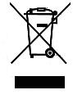
Meaning of crossed –out wheeled dustbin:
Do not dispose of electrical appliances as unsorted municipal waste, use separate collection facilities.
Contact your local government for information regarding the collection systems available.
If electrical appliances are disposed of in landfills or dumps, hazardous substances can leak into the groundwater and get into the food chain, damaging your health and well-being.
When replacing old appliances with new ones, the retailer is legally obligated to take back your old appliance for disposals at least free of charge.

Heat Design, 30-60 Hawthorn Road, Western Industrial Estate, Naas Road, Dublin 12.
T: 01 408 9192 F: 01 408 9193

